Production Design Plan (PDP)
Class of 2014
Contents
What is it? 2
What needs to be in it? 3
Intention Statement 4
Audience Statement 4
Style and Genre 7
For the Film Makers 10
For the print and photography people 13
Assessment of your SAT 17

What is it?
An organised document that is made up of all of the pre-production planning for your product.
What isn’t it?
It’s not a visual diary, such as one you might do in Studio Art or Art. Therefore, you don’t include pages and pages of ideas.
What is it worth?
Here’s where it gets tricky. Overall, your SAT is worth 37% towards your Study Score and your PDP is a very important component of that. You have to have completed your PDP successfully by the end of Unit 3 to pass the unit.
In order to understand how much your PDP is worth of that, you need to understand how your PDP is assessed.
Your SAT is assessed using the criteria below and I have indicated which criteria also involves assessment of your PDP. For further information about how your SAT is assessed see the later section.
Use of Media equipment, applications and/or processes to present ideas and/or achieve
particular effects in a Media form

Development and preparation of a media production design plan in a selected media form for a specified audience | Yes
Application and understanding of styles, codes and conventions appropriate to the selected  media form | Yes
Realisation of an individual or a distinctive media product appropriate to the intention for the selected audience/s that demonstrates appropriate style

Skill in the operation of equipment and use of materials and processes appropriate to the
selected media form

Management of the production of a media product

Realisation of the production design plan in the media product | Yes

What needs to be in it?
There are some bare minimum requirements that MUST be in your PDP in order to pass the unit, then there are requirements that I would expect of every student in this class. Finally, there are extra additions that individuals can make who are hoping to achieve in the top grades for this subject.
Audio Visual | Radio | Photography and Print
Intention | Intention | Intention
Audience | Audience | Audience
Techniques for how you will engage your audience | Techniques for how you will engage your audience | Techniques for how you will engage your audience
Style and/or Genre | Style and/or Genre | Method of presentation and exhibition
Storyline or outline of content | Storyline or outline of content | Style/Genre
Script | Sound design | Subjects and or topic
Storyboard | Sound capture: microphones, position and movement | Location
Shot List | Script | Lighting
Location | Location | Mock ups of image composition and/or page layout designs
Edit details and transitions | Dialogue, narration and or interview questions | Typography (if relevant)
Lighting | Edit, layering and/or sequencing details | Paper stock and method for printing (*note you MUST print yourself and you MUST print at school)
Music and/or Sound Effects | Music/Sound Effects | Content eg. text, images, illustrations, graphics
Titles and credit sequences | Titles and credit sequences | Specialist Techniques eg. selective focus, manipulating contrast, toning etc, hand colouring etc.
Production Timeline | Production Timeline | Production Timeline
Export settings and details of reception | Export settings and details of reception | Any models used along with casting choices
Main character descriptions and casting choices | Main character descriptions and casting choices | Equipment that you’ll use and the stylistic reasons for your choice
Equipment that you’ll use and the stylistic reasons for your choice | Equipment that you’ll use and the stylistic reasons for your choice | Short interviews with members of your potential audience about your idea and any feedback they give you that you will incorporate
Short interviews with members of your potential audience about your idea and any feedback they give you that you will incorporate | Short interviews with members of your potential audience about your idea and any feedback they give you that you will incorporate | Any relevant costume design and or set design/prop sourcing
Costume and any relevant set design/ prop sourcing

Intention Statement
What it is:
This is a 300-500 word statement that articulates the purpose and overall concept for your media product. In your intention statement you may address the following dot points:
- What ideas, concepts, themes or issues do you want your product to explore?
- What do you want people to think about or consider when they engage with your product?
- Why are you making this product? What purpose does it serve? (aside from being a school assignment!)
- What other work has inspired this product?
- What conventions would people need to be familiar with to appreciate this product?
- What symbolism and/or motifs are you using in your work and for what intended purpose?
What isn’t it:
This isn’t a place to document the entire storyline of your video or to describe in detail each and every one of your photographs (there will be plenty of time for that later!)

Audience Statement
What it is?
This is one of the most important aspects of your PDP, in fact criteria 2 which you are assessed against states ‘Development and preparation of a media production design plan in a selected media form for a specified audience’. So if you don’t nail your ‘specified audience’ it’s hard to be successful here.
This is a 300-500 word statement articulating your target audience/s. It should include a description of who they are, what their expectations and knowledge might be and why they would be engaging with your media product. In your audience statement you might address the following dot points.
- Some key demographic information (eg. age, gender, where they live, income levels etc.) *note. sometimes not all of these are relevant but most of the time they are so be specific, it’s ok if you feel like you’re stereotyping because in a way that’s what you are doing.
- What other media forms and texts does your audience engage with?
- What knowledge does your audience bring with them? What conventions etc. are they aware of and expecting from your product?
- What aspects of your media product will they engage with and why?
What it isn’t
This isn’t a brief generalisation eg. ‘my target audience is anyone who loves to experience love and passion’.
Example
Straight up, let us know what media form you are working in and what genre/style.
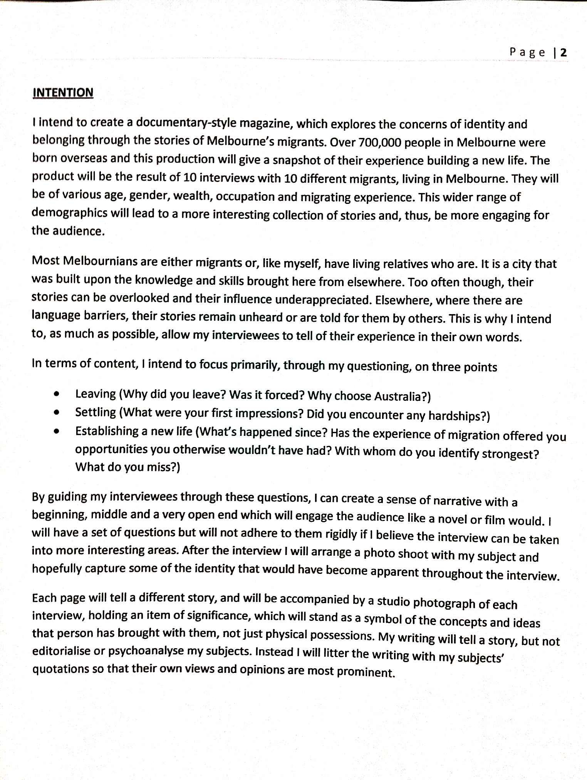
Give a rationale for why your concept is important/interesting
Sometimes it’s useful to point out what you are NOT on about, in order to clarify your concept to a reader
Feel free to use dot points to quickly and succinctly outline some key ideas
Statement by Mike Matters, NHS Media
Example
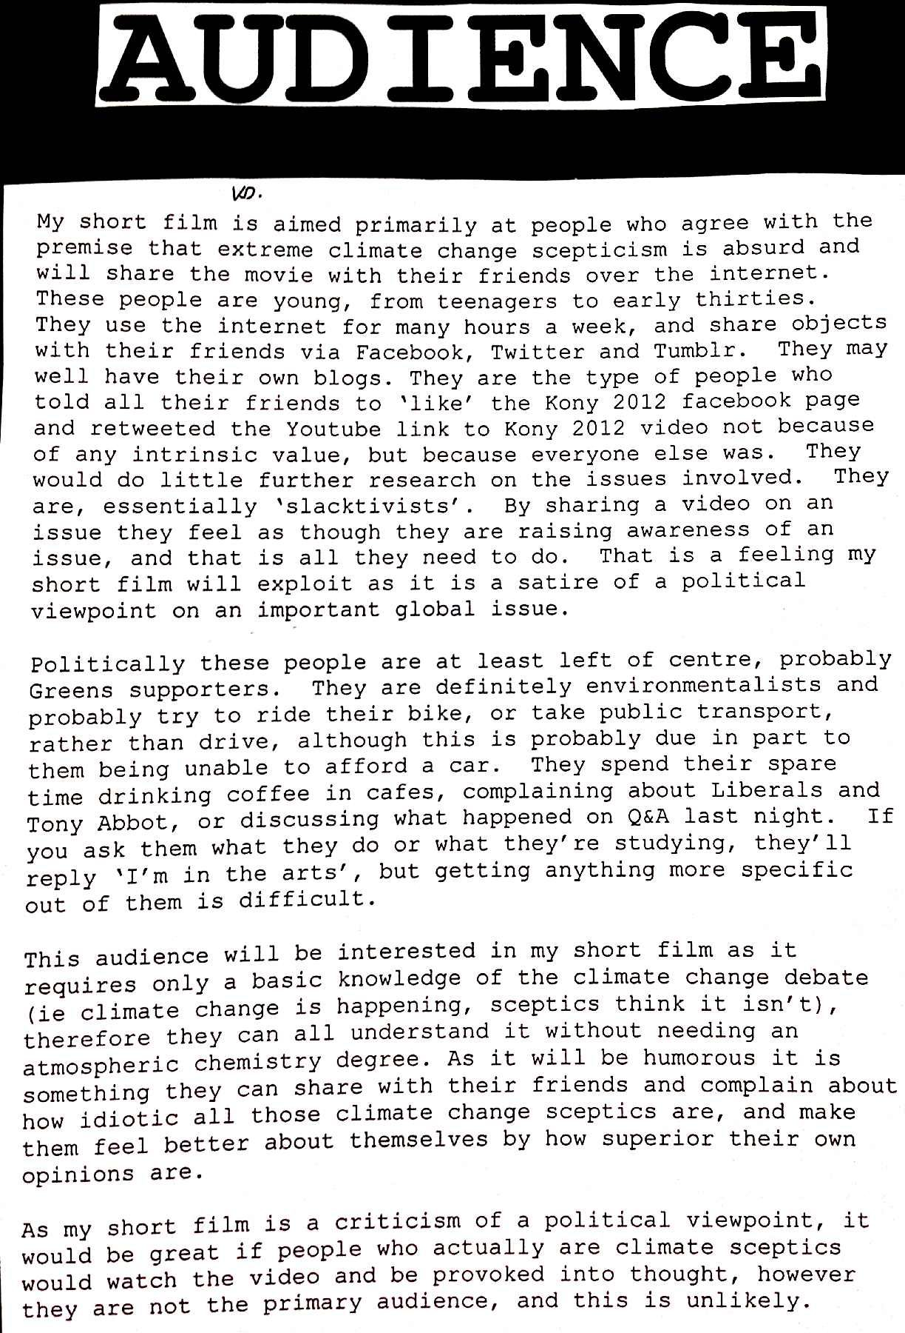
Explain why you audience will be interested in your product.
Political views may be relevant
Does your audience belong to a group that is commented on in the Media. ‘rev-heads’, ‘hipsters’
Use specific examples to help highlight your audiences activities.
Discuss what other media your audience uses and how they engage with it
Statement by Lucy Foskey, NHS Media

Style and Genre
What it is
This one is tricky and some people have a great deal of trouble with it so hopefully this makes it clear to everyone. Style refers to a particular appearance or procedure for how something is done. It refers to the manner in which it is done as separate from its content.
In media, there are visual styles which share common conventions and therefore look as though they belong together.
So, what is Genre? Well, genre is a category of a media form that shares common conventions. These are categories that don’t just share a style but also might share content.
Some ways to talk about style
Type of style | Examples
Stylistic technique | Handheld camera, chiaroscuro lighting, long takes, desaturation, black and white, panoramic, naturalistic, lomography
Stylistic movement | Film noir, Surrealism, German Expressionism, French New Wave
Noted media practitioners who have established styles | Hitchcock, Burton, Tarantino, Gilliam
Other words to describe style | Bohemian, romantic, industrial, eclectic, cold, warm, grungy, chic
Some ways to talk about genre
Media form | Examples
Film | Sci-fi, rom-com, western, indie, comedy, dramedy, thriller, horror
Print | Fashion, music, bridal, fitness, travel, cooking
Photography | Photo essay, documentary, travel, nature, underwater, artistic, glamour, landscape, portrait

To note
The difference between style and genre can be tricky and media commentators themselves argue about it. Check out this argument about wether or not film noir is a style or a genre. In the end don’t get too caught up about it, check with me if you are unsure and for some of the tricky ones I might be unsure to (as are the experts!).

Example
There’s a few different ways you can do this. Some people describe the genre like the example below.
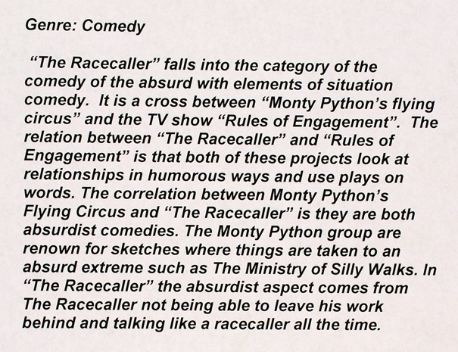
Relate the conventions of the genre back to your piece
Identify any sub genres it belongs to and describe other texts that are similar
By Jack Wynne: Season of Excellence
Others, use a combination of text and imagery
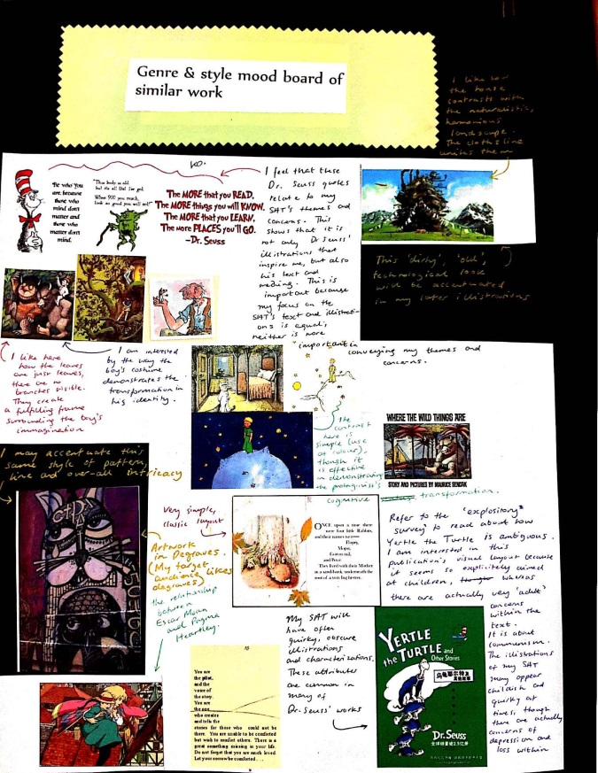
By Greta Giovinazzo, NHS Media
If you do this it is essential that you annotate the images that you have included and describe how they relate to the genre and/or style of your product.
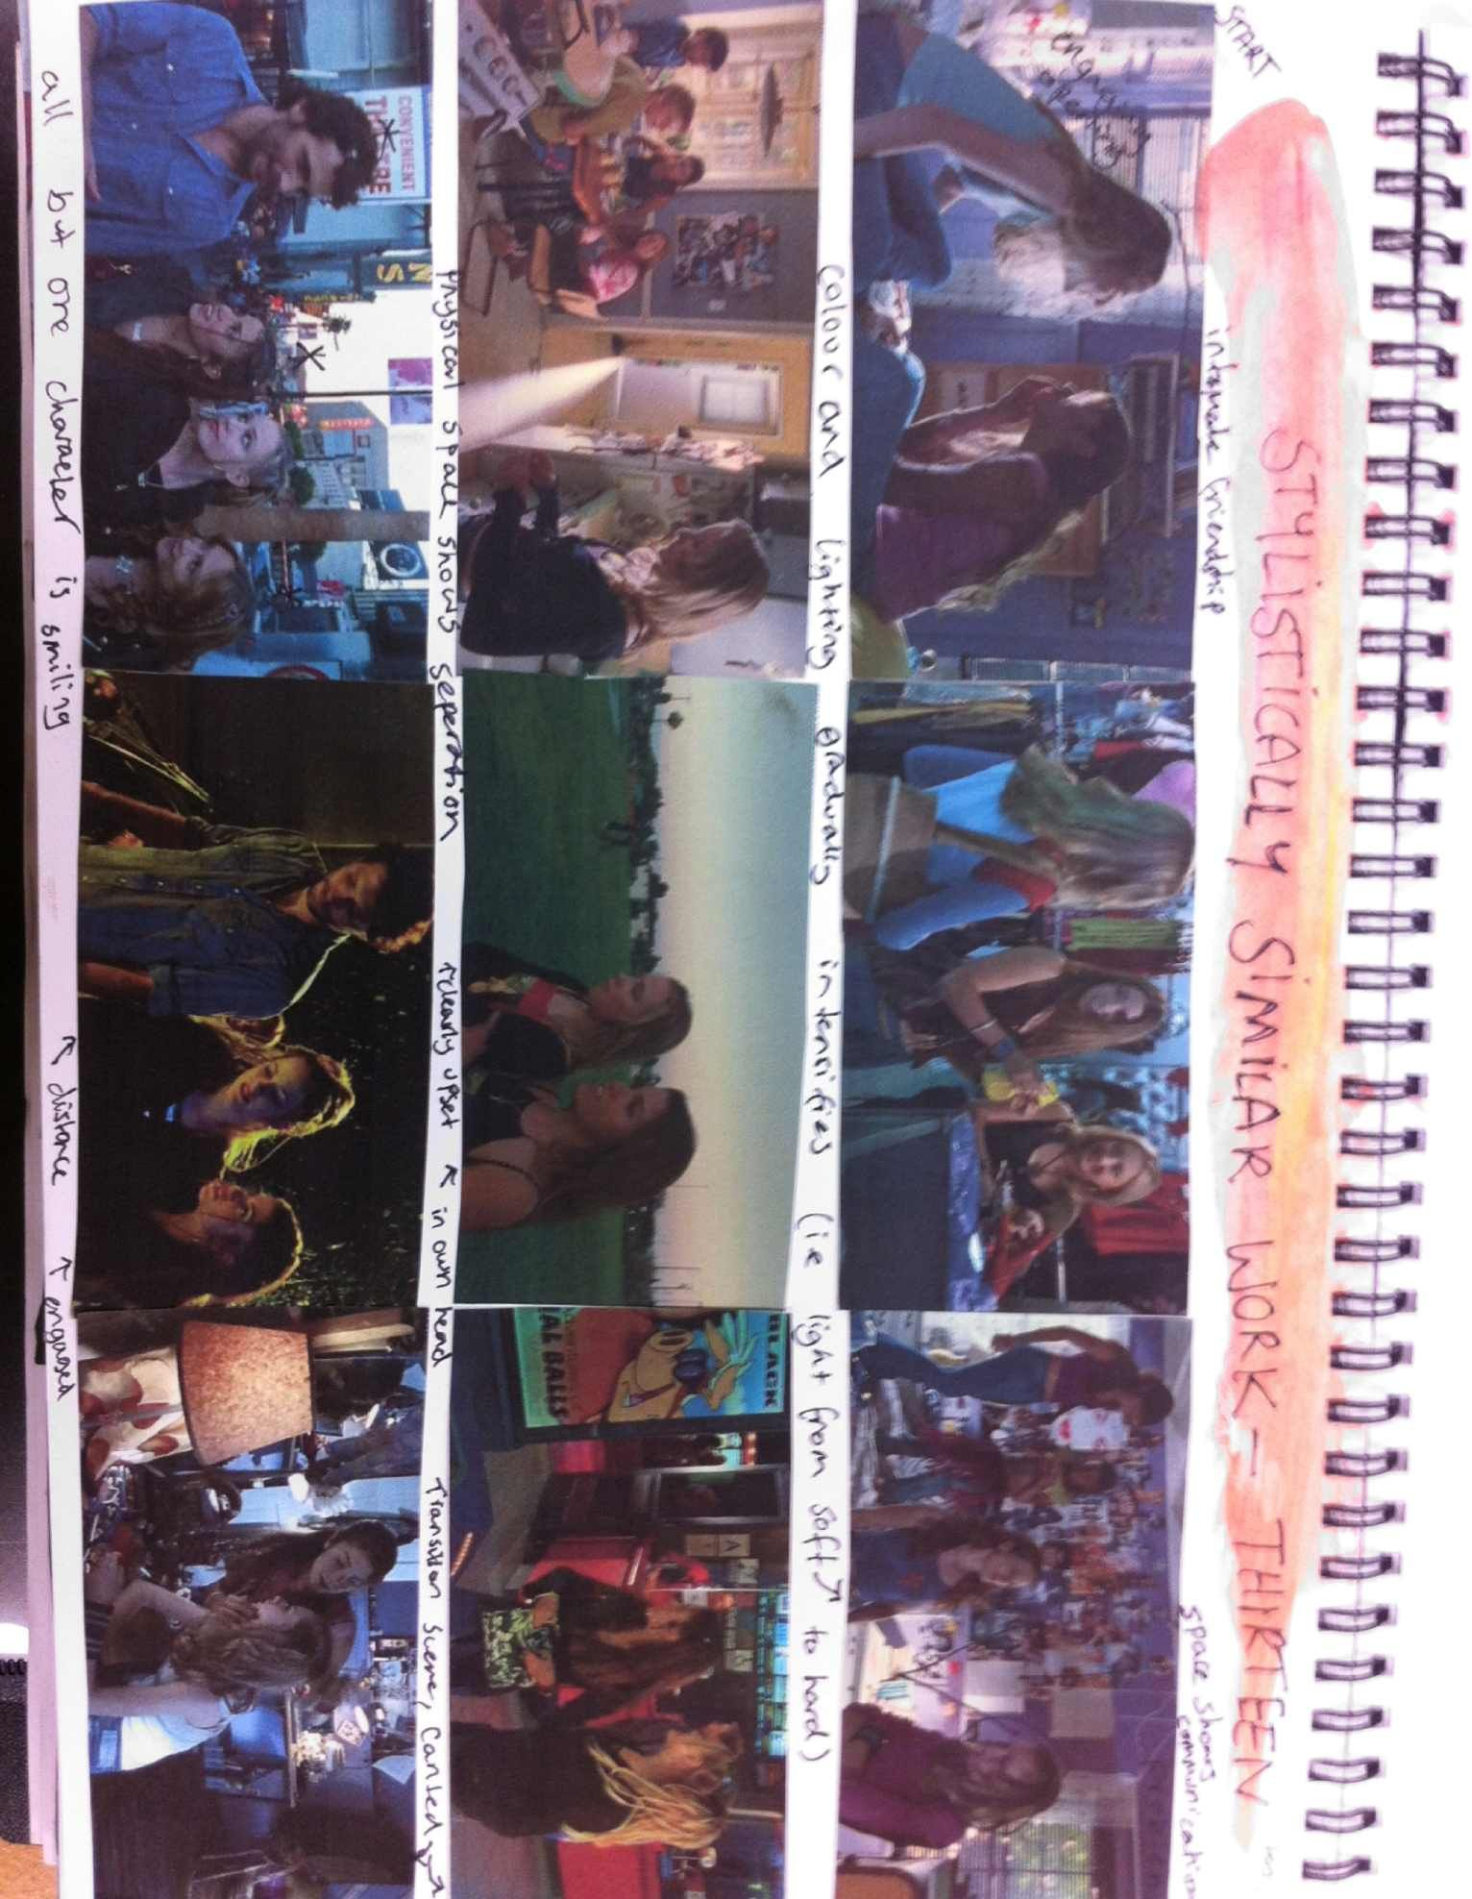
If you’re doing film, one handy method is to screen cap the work of a director who is using a similar style to your film.

Then you annotate the screen caps, describing how the work is similar to yours.
It’s a bit like analysing mise en scene!
By Isabella D’Souza, NHS Media

For the Film Makers
Script
This needs to be correctly formatted using standard conventions. Check out this link at script frenzy for an excellent summary on standard script writing.
Most professionals say that 1 page of correctly formatted script should equal 1 page of action in a film. So that gives you an idea of how long it should be.
You can also use freeware such as Celtx which helpfully formats the script for you! Download it here . Note, there’s a free version and a pro version and you only need the free version.
Storyboard
So storyboards often get a bad rep from naïve directors. Below is a great rationale for why you need a storyboard (along with the obvious, you can’t pass without one!)
Storyboarding has a variety of uses and one of those uses are why its so frowned upon by naive directors. That use is when a director storyboards just to visually check that the shots will cut together correctly and look like what he or she intends. Of course, since directors are total geniuses with minds of pure gold, they never have to double-check their own shotlist to make sure that the compositional elements will pan out as intended. That’s just crazy talk. A gifted visionary can see the whole movie in his or her own head, fuck storyboarding.
But for what it’s worth, sometimes it’s useful even to the director to look over the storyboards to remember how the whole thing is to be blocked and composed.
But one of the most significant uses of storyboard cannot be argued away by delusions of visionary-ness. And that is that if all else fails and you’re having a difficult time explaining the shot you want to your crew, you can grab the storyboards and point. “THAT, it needs to look like THAT.” Storyboards in this manner are essential for choreography, production design, special effects, and visual effects. Say you want a ninja fighting a dinosaur. The ninja will be shot in real life but the dinosaur is 3D. You need the storyboard so that you know where to frame the ninja when you’re shooting it so that you have room for the dinosaur.

The easiest way to design a storyboard is the old pen and paper, it looks like the picture below | You can always step it through with a camera if you are really opposed to drawing, however the downside of this is you need to organise yourself and mock actors for a ‘mini’ shoot.
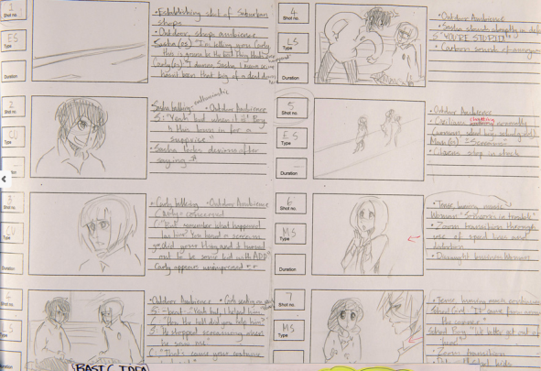 | 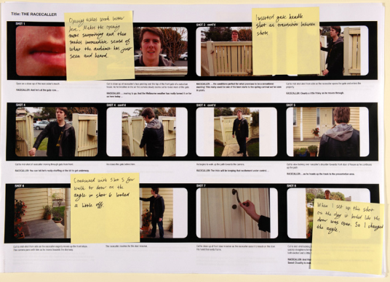

Some drawing tips

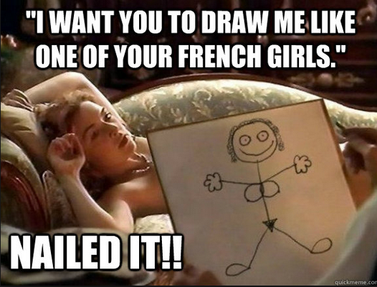
Stick figures are not acceptable but you don’t need to be a fantastic artist to draw a storyboard. What you want to convey is the shot size and angle along with the composition in the shot
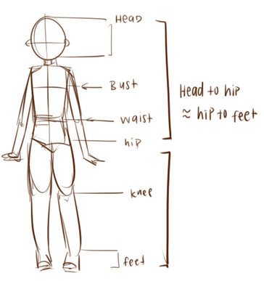 | Use circles and shapes to help build a figure
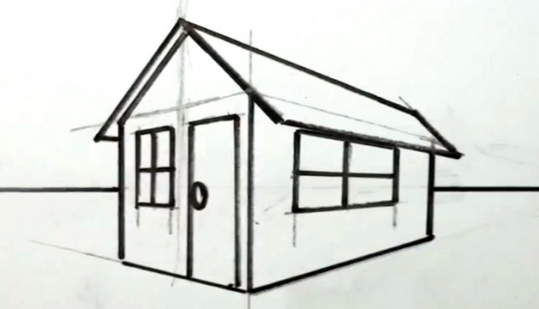 | Remember year 8 VCD? Good ole 2 point perspective? Very handy for drawing houses and buildings.  Just google ‘how to draw in 2 point perspective’ for a refresher

Indy Mogul even have a video about how to storyboard when you’re not great at drawing which you can watch here

Students often ask “how detailed does my storyboard need to be?” and “do I have to draw every single shot?” The answer to these are, the more detailed the better and the closer you come to every single shot the better. Of course things will happen spontaneously while shooting which may change your storyboard, this is a natural part of the process and you just jot these genius ideas down on a post it and stick it in as you go.
Detail in your storyboard is a great way to distinguish yourself from other students. Those that do a simple job are demonstrating basic skills and this can impact on the effect of their overall PDP. Those that do a thorough and detailed job are demonstrating stronger skills and this has a very positive impact on the overall PDP.
Low | Approximately 5 pages
Average | Approximately 10-15 pages
Superstar | 30+

Shotlist
You’ll probably find that your shot list is a real life saver and for many students it’s the document that they refer to the most during the production of their film. A shot list is basically a long list of all the shots in your film. You can use this great excel spreadsheet found at www.lessonbucket it’s really useful because it’s pre-formatted and you can sort your shots by location etc. for ease of shooting.

For the print and photography people
Method of Presentation and Exhibition
Let’s take photography people for a minute. This section is where you need to visualise and plan how you will present your images and where they would be exhibited. Some things to consider:
- Location of exhibition (eg. inner city gallery, café etc.)
- Size of paper (A4, A5, A3, A1*)
- Border colour or borderless
- Mounting (mount card, foam core etc)
- Order of images
- Presentation style (all in a row, a grid, 3 by 3 square etc.)
*We have a brand new A1 printer in the library just waiting to be used by one of you!
Keep in mind that you have to do all of the mounting yourself. Most students do this by purchasing foam core (you can get it in black or white and variety of sizes) and using double sided sticky tape to mount their photographs on top. 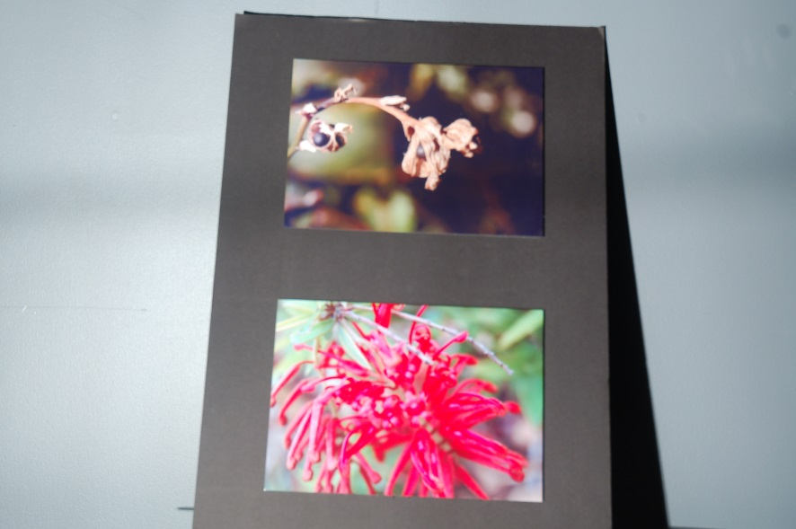
Here a student has mounted two smaller pictures on to an A4 sheet of black foam core.
For print people
The main methods that students use for print production are to create magazines that are bound or to present their finished pages as layouts. In my experience, students who bind their magazines come across a lot of issues. You have to bind it yourself and amateur binding is time consuming and often looks, well, amateurish. I would encourage you to present your finished pages as layouts, meaning you would present the pages just like the photography people above (perhaps mounting them onto foam core).

Paper stock and Methods of Printing
You’ll need to make decisions about what kind of paper stock you are going to use and purchase the paper. When considering paper stock you want to think about the weight of the paper which is how thick it is (measured in GSM) and the finish of the paper (gloss, matte, pearl). Different papers are associated with different styles and genres so you should ensure that your choice matches your chosen style .
Options for Printing
- The printer that we have in the Media room (Canon Pro 9000) prints up to A3 and information about it (including what paper it supports) can be found here
- You can print to the colour laser printer in the library, which is a good option for those who are doing a magazine.
- We have a new printer in the library which prints up to A1, I haven’t used it yet so we would need to experiment but it’s certainly an option.
Example of what you might write about your paper stock | Example of the front cover of a student magazine shot on the colour laser printer in the library
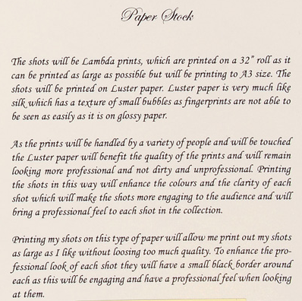  Written by Ashley Muraca, Season of Excellence | 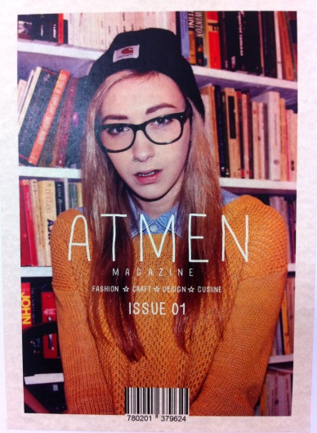  Magazine cover created by Orson Passi, NHS Media

Mock ups of Image Compositions or Page Layouts
This is like your version of a storyboard. You need to draw a design for what each photograph or each page of your magazine will look like. Here are some examples:
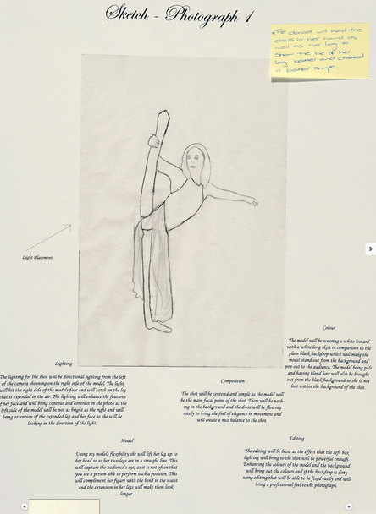  By Ashley Muraca, Season of Excellence | 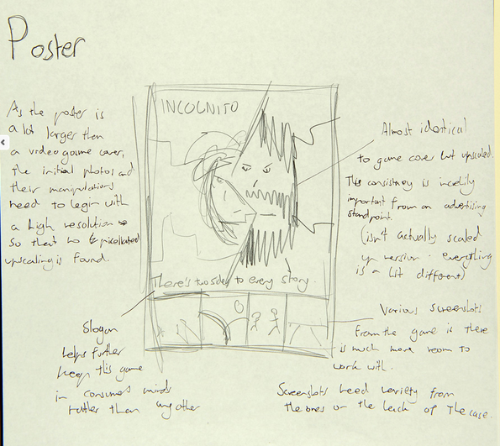  By Megan Jenkins, Season of Excellence
The student above has also included descriptions of ‘lighting’ ‘colour’ ‘model’ and ‘editing’ on the same page as the mock up. This makes it really easy to articulate everything you need for each of your images. | For print, you need to show how the text, graphics, images etc. are all going to ‘look’ on the page. You need to annotate these also to explain the choices you have made.

Typography
If you have text in your product then you need to decide what typography you are going to use and why. This isn’t a VCD folio so you DO NOT need to do pages and pages of typography designs and trials and errors. You simply include the typography choices you have made for your product with a description as to why.
Check out www.dafonts.com to download fonts for your print production. Most of these are free.

Here are some terms you can use to describe typography:
Characteristics of Type:
Point Size: How large or small your type is
Line Length: How long will your line go for before you start a new one
Leading: The distance between two lines
Kerning: The distance between two letters

Ok, so that’s an outline of some of main components of your PDP but there are many more in the coloured list that you need to include. For help I would suggest that you check out past PDP’s from students at http://www.atomvic.org/season-of-excellence/2012-design-plans/

Assessment of your SAT
It’s worth a huge chunk of your grade so you need to be clear around how it’s assessed.
There are two parts to your assessment:
Part 1: Unit 3, at the end of Unit 3 you need to have submitted your PDP and your two finished skill exercises when you do that you are awarded an ‘S’ for Unit 3 and you are given back your PDP so you can make your product.
Part 2: Unit 4, early in term 3 your product is due and you’ll need to hand in your finished product AND hand back your PDP with any notations that you have made. I then fill in the following criteria sheet and award you marks accordingly.
You are assigned a mark on a 10 point scale
1-2 Very Low | 3-4  Low | 5-6  Medium | 7-8  High | 9-10  Very High

There are seven criteria
1 | Use of Media equipment, applications and/or processes to present ideas and/or achieve  particular effects in a Media form | These are the 2x skill exercises and the written documentation that you do with them.
2 | Development and preparation of a media production design plan in a selected media form for a specified audience | This is your entire PDP
3 | Application and understanding of styles, codes and conventions appropriate to the selected  media form | This refers to your ‘style/genre’ page /s in your PDP along with the way in which you apply those conventions in your finished piece
4 | Realisation of an individual or a distinctive media product appropriate to the intention for the selected audience/s that demonstrates appropriate style | This means your finished product is well structured, coherent, consistent in quality throughout. It refers to how well the ideas and concepts are communicated in the finished product
5 | Skill in the operation of equipment and use of materials and processes appropriate to the  selected media form | This means that you understand the limitations and possibilities of the equipment you are using and that you have skilfully completed your product with this in mind.
6 | Management of the production of a media product | This is evident in a polished and refined finished product.
7 | Realisation of the production design plan in the media product | This means that you have developed a highly detailed plan and that your finished product matches that plan. There should be evidence that you have used the plan during the process (through annotations and notes) and these should demonstrate that you developed strong skills and knowledge.

